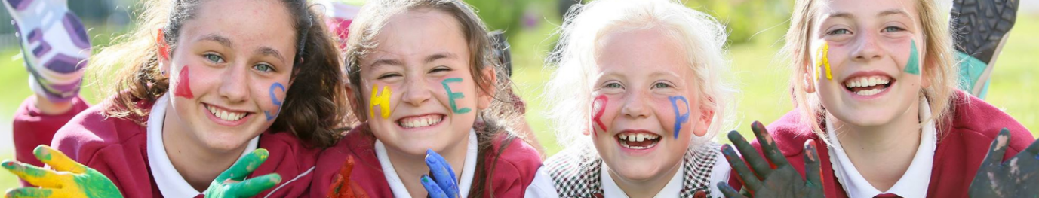
Dear Our Lady of Lourdes NS Families,
Following on from the discussions to support families with fun and engaging childcare solutions beyond the school day throughout the academic year and during school closures, we’re delighted to inform you that we have partnered with Sherpa Kids as the school’s NEW Before, After School & Holiday Programmes opening from 1/12/2025 at Our Lady of Lourdes NS.
NEW Before, After School & Holiday Programme coming to Our Lady of Lourdes NS on 1/12/2025
Sherpa Kids is Ireland’s leading school age childcare provider, proudly supporting families for over 10 years across more than 120 locations nationwide. We offer an enriching experience that goes beyond the traditional school day — providing a safe, nurturing, and fun environment where children can thrive. Sherpa Kids programmes combine engaging, play-based activities with practical support for families — offering affordability, convenient hours, and assistance with school pick-up and drop-off through our Junior Hours.
- Enriching activities for school aged children 4-12 years
- Market-leading term time and holiday programmes
- Build social skills and make new friends
- Weekly or Adhoc booking options
- NCS Subsidy Accepted
- Homework Supervision
- Tusla Registered Services
- Extended Hours (Up to 6pm Mon-Fri)
- Trained and Garda Vetted Staffs
- Breakfast & Snack Provided
Check out further details of Sherpa Kids' services below:
🌅 Before School Programmes (Rise then Shine)
Sherpa Kids Before School Programmes prepare children’s minds and bodies for a busy day at school day while offering a hassle-free morning for families with no worries when dropping their children early in school. A healthy and nutritious breakfast is offered to keep them energised throughout their day while focusing on an active start with activities that stimulate concentration and provide well-being.
- Rise then Shine / Before School starts at 7.50 am and runs until the start of school.
👉 Book now at: https://enrolmy.com/sherpa-kids/book-now/327-LLNSD-01Dec25-Jun26-Rise-Then-Shine-Before-School-and-Stay-and-Play-After-School

👉 Find out more at: https://www.sherpakids.ie/before-and-after-school/rise-then-shine-before-school/

🤸 After School Programmes (Stay and Play)
Sherpa Kids offers after-school programmes starting when Junior and Senior infants finish their classes and extending beyond school hours. During their time at Sherpa Kids in the afternoon, they’ll have homework support, time to play freely and dive into engaging and fun games and activities fostering friendship, teamwork, and well-being.
- Stay and Play / Junior Hour After School starts at 1.30 pm until older siblings are picked up.
- Stay and Play / After School starts at 1:30 pm and runs until 5:30 pm.
👉 Book now at: https://enrolmy.com/sherpa-kids/book-now/327-LLNSD-01Dec25-Jun26-Rise-Then-Shine-Before-School-and-Stay-and-Play-After-School

👉 Find out more at: https://www.sherpakids.ie/before-and-after-school/stay-and-play-after-school/

🌞Holiday Programmes (Holiday HQ)
Sherpa Kids jam-packed daily schedule uniquely caters for each child’s talent and interests, forging an amazing holiday experience during school closures for children. Holiday HQ is the ultimate destination for kids seeking an unforgettable break from their school routine. From thrilling outdoor adventures to creative workshops, cooking classes, and interactive learning sessions, our expert programme team offers a dynamic mix of engaging activities and enriching experiences.
We also ensure that every child’s holiday is not just entertaining but an opportunity for growth. Helping them to build new friendships, explore their interests, and return to school with unforgettable memories. We’re the experts in fun!
- Holiday Programmes: runs through the academic year every school closure from 8:30 am to 5:30 pm during October Mid Term, February Mid Term, Easter and Summer.
👉 Find out more at: https://www.sherpakids.ie/school-holidays/holiday-hq/

National Childcare Scheme
🎉 National Childcare Scheme
Sherpa Kids is a Tusla registered service which means they support and accept the National Childcare Scheme across all their services and programmes, including Holiday Programmes. As a parent/guardian, you are entitled to claim a discount of €2.14 up to €3.75 per hour off your bill. 🎉
👉 Find out more: https://www.sherpakids.ie/parent-support/national-childcare-scheme-ncs/
To learn more about Sherpa Kids:
- Sherpa Kids Website: https://www.sherpakids.ie/.
- Sherpa Kids Story: https://www.sherpakids.ie/about-us/
- Support: https://www.sherpakids.ie/parent-support/
- FAQs: https://www.sherpakids.ie/parent-support/frequently-asked-questions/
- Sherpa Kids Locations: https://www.sherpakids.ie/find-us/
Please, if you require any further information contact Sherpa Kids directly at support@sherpakids.ie and they’ll be happy to assist you.
Yours sincerely,
Our Lady of Lourdes NS

